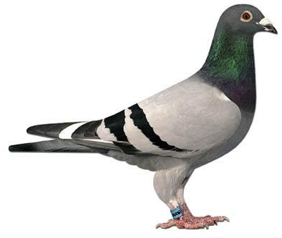

5017 NJ 22
B/B

0458/18 NJ B/B
TOM LOCK

0020 LPU B/B
VD PASCH

5017 NJ 22
B/B

